Project Design Phase
Technology Stack (Architecture & Stack)

Team ID | SWTID1745140705
Project Name | Shopez: E-Commerce Application
Maximum Marks | 4 Marks

Technical Architecture:
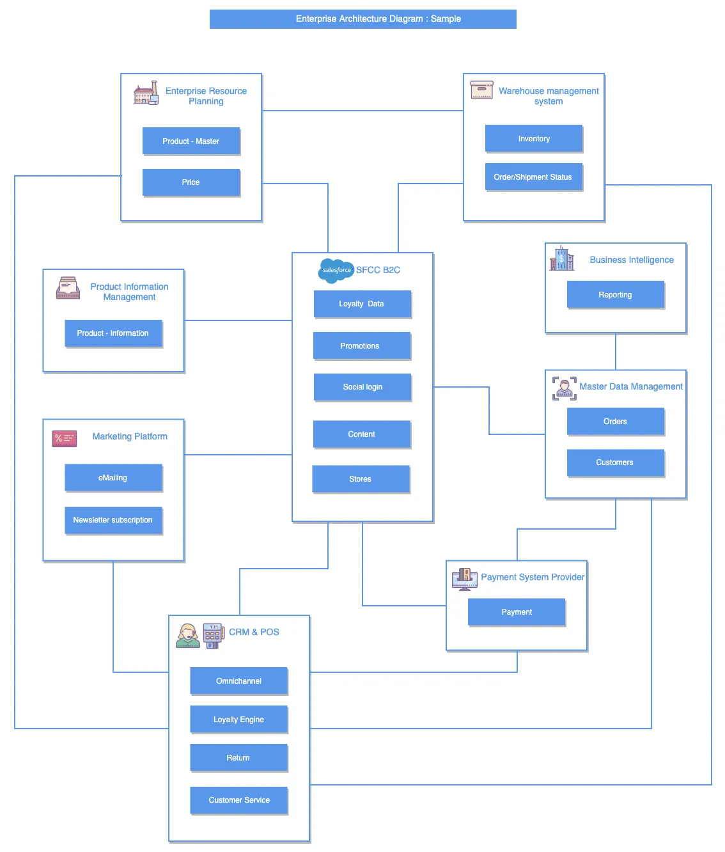
Table-1: Components & Technologies:
Sl.No | Component | Description | Technology
 | Enterprise Resource Planning |  | SAP, Oracle ERP, Microsoft Dynamics
  Manages core business processes like product
  master data and pricing.
 | Warehouse Management System
  Handles inventory tracking and shipment/order
  status updates.
  Manhattan WMS, SAP EWM, Oracle
  WMS
 | Product Information Management | Centralizes and manages product data for accuracy across platforms. | Akeneo, Salsify, Informatica PIM
 | Marketing Platform | Executes marketing campaigns including emails and newsletters.
  Mailchimp, Salesforce Marketing
  Cloud, HubSpot
 | CRM & POS |  | Salesforce CRM, Oracle POS, Lightspeed, Square POS
  Customer Relationship Management and
  Point of Sale for loyalty, returns, etc.
 | SFCC B2C (Salesforce Commerce Cloud) | Central eCommerce platform handling promotions, content, loyalty, etc. | Salesforce B2C Commerce (formerly Demandware)
 | Master Data Management | Maintains consistent data across systems—orders and customer records. | Informatica MDM, IBM InfoSphere, Talend
 | Payment System Provider | Manages and processes customer payments securely. | Stripe, PayPal, Adyen, Razorpay
 | Business Intelligence |  | Power BI, Tableau, Looker, Qlik
  Analyzes business data and provides reporting and dashboards.

Table-2: Application Characteristics:
Sl.No | Characteristics | Description | Technology
 | Centralized Business Logic |  | SAP, Oracle ERP, Microsoft Dynamics
  Core backend system managing product
  master data and pricing.
 | Real-time Inventory & Shipment Tracking | Tracks stock levels and order/shipment status for fulfillment.
  SAP EWM, Manhattan Associates,
  Oracle WMS
 | Centralized Product Data | Maintains consistent and updated product details across platforms. | Akeneo, Salsify, Informatica PIM
 | Automated Customer Outreach | Runs targeted campaigns via email and newsletters.
  Mailchimp, Salesforce Marketing Cloud, HubSpot
 | Secure Payment Processing | Facilitates encrypted and compliant online payments. | Stripe, PayPal, Razorpay, Adyen

